SUNDAY | MONDAY | TUESDAY | WEDNESDAY | THURSDAY | FRIDAY | SATURDAY
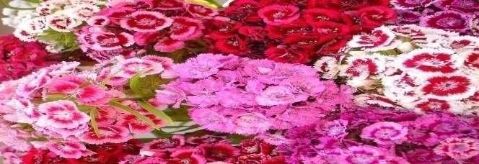 |  | 1  10a Wal-Mart  11a Garden stroll  2p Puzzle Mania  3:30p Old Maid | 2  9a Massage  10a Play/w Chloe H3  2p Exercise  3p Play Clue | 3  9:30a UNO  10:30a Music &Dance  1:30p Nail care&Color  2p Play cards | 4  10a Exercise House 1&2  11a Play with Chloe H3  1p Music and Dance  2p Bingo | 5  10a Hair and Nails  11a Cut Roses make  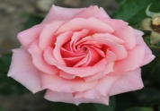  Arrangements  1p Movie
6  9a Church CH 372  10a Puzzle Mania  1p Exercise all Houses  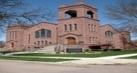  3pRead | 7  9a Newspaper exchange  10a Beauty Shop H3  10a Exercise  2p Loteria | 8  9a Grocery Game  10a Wal-Mart  1p Reading/Napping  2p Play w Chloe H3  3p Read | 9  9a Arts & Crafts  10a Farmers Market  1p Garden Stoll  2p Exercise | 10  9:30a Word Search  11:00a Music in the garden w/ Hon. John  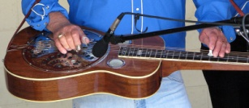 | 11  9a Puzzles  10a Exercise House 1&2  11a Gardening  2p Bingo | 12  10a Sunbathing in the  Garden  1:30p Movie
13  9a Church CH 372  11a Arts & Crafts  1p Relax  3p Garden Stroll | 14  9a Dear Abby  10a Dollar General  2p Exercise House 1&2  3:30 UNO | 15  9a Read Horoscope  & Dear Abby  10a Wal-Mart  2p Play Cards  3p Read & Nap | 16  9a Arts & Crafts  10a Stroll the Gardens &  Cut Roses  2p Exercise House 1&2 | 17  9:30a UNO  10:30a Music and Dance  1:30p Nail Care & Color  3:30p Word Search | 18  9a Read Horoscope  10a Exercise  11a Play with Chloe  1p Concert w/ Suave H2  2p Bingo | 19  9a Color  10a Coffee and Chat  11a Garden Stroll  1:30p Movie
20  9a Church CH 372  10:30a Relax & Enjoy  FATHERS DAY | 21  9a Read Horoscope&  Dear Abby  10a Beauty Shop House3  2p Exercise  3:30p Jenga | 22  9a Crossword  10a Wal-Mart  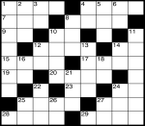  2p Garden Stroll  3p Jenga | 23  9a Arts & Crafts  10a Farmers Market  1p Exercise  2p Relax  MARY BDAY | 24  9:30a Jenga  10:30a Music Dance  1:30p Music & Dance  2:30p Nails  3:30p Play Cards | 25  9a Arts and Crafts  10a Exercise  2p Bingo  NORMA BDAY | 26  10a Nails  11a Garden Tea Time  1p Movie  3p Cards
27  9a Church CH 372  10:30a Read Newspaper  1p Exercise all Houses  3p Relax | 28  9a Current Events  10a Dollar Tree  2p Exercise  3p UNO | 29  10a Wal-Mart  11a Crossword  2p Read  3p Relax | 30  9:30a Arts &Crafts  10a Farmers Market  1:30p Exercise  2:30 Match Game

